EXPERIMENT – 6
TO UNDERSTAND EDA – QUANTITATIVE AND QUALITATIVE
Aim:
To understand quantitative and qualitative of EDA

Procedure:
1. Import all the necessities
2. Upload default dataset ‘tips’
3. Use pandas to read and make it as Data Frame
4. Then perform various plots and joints using seaborn and other libraries

Program
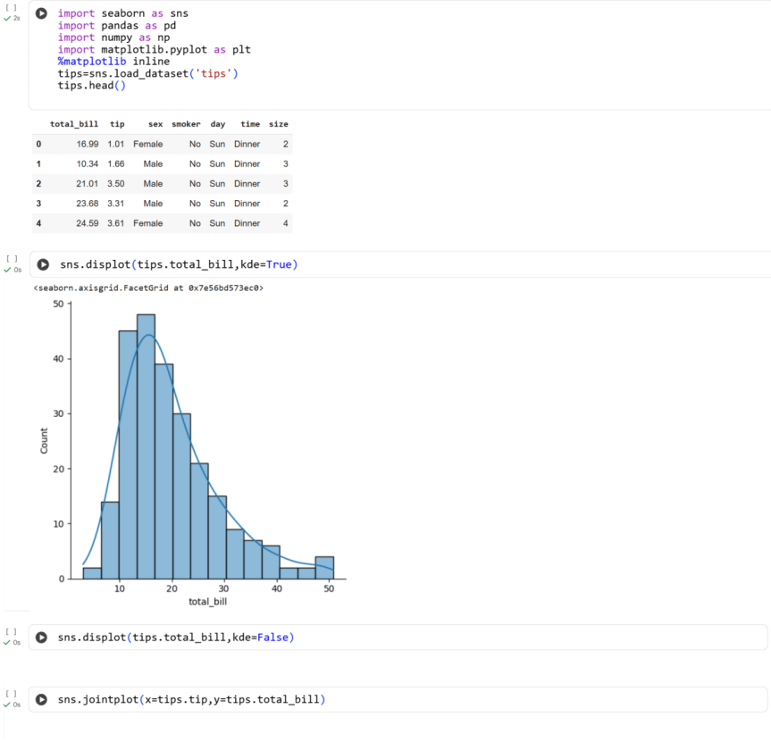
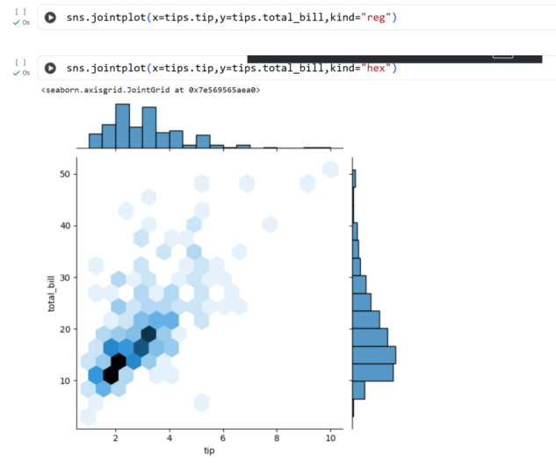
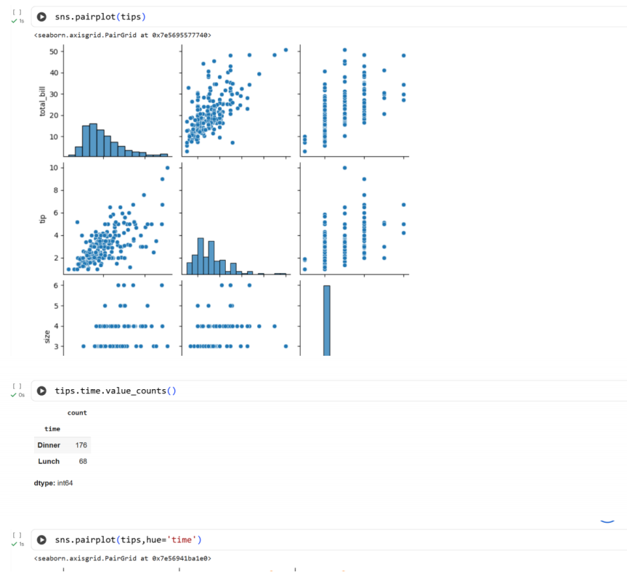
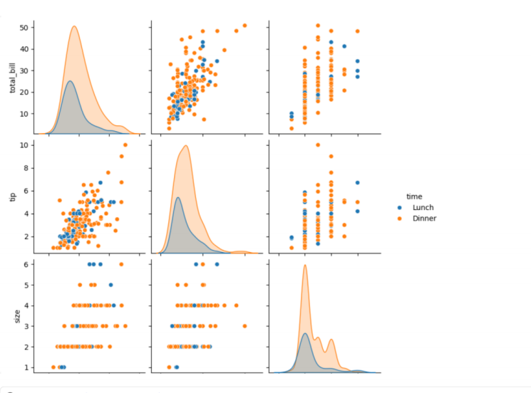
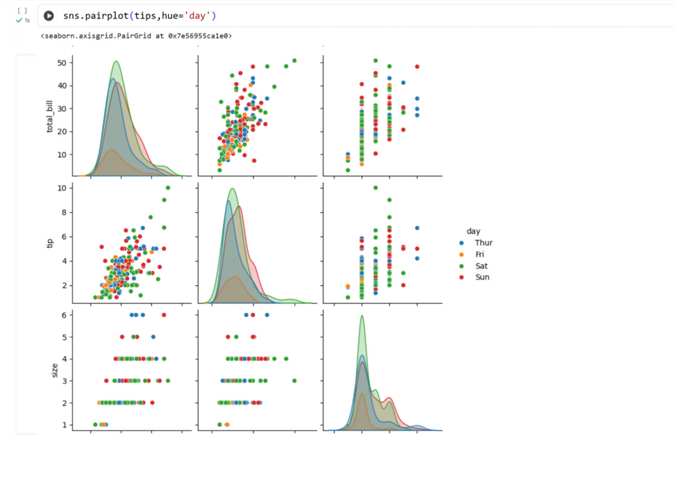
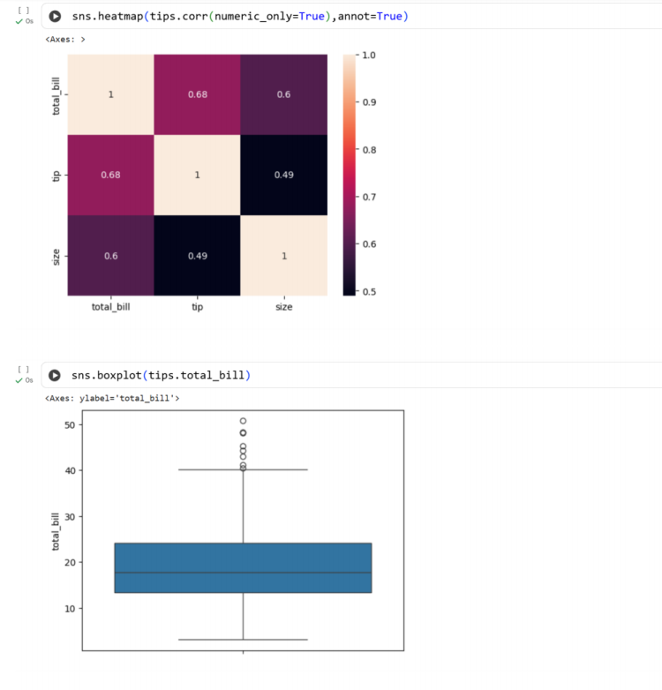
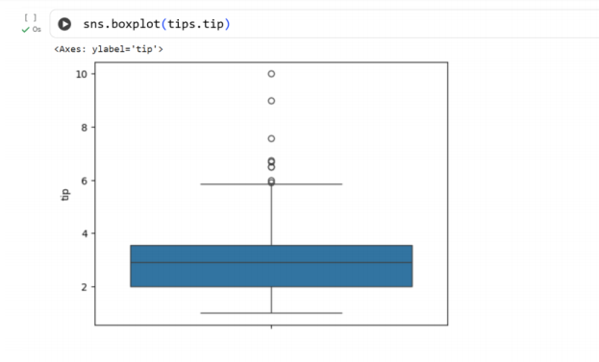
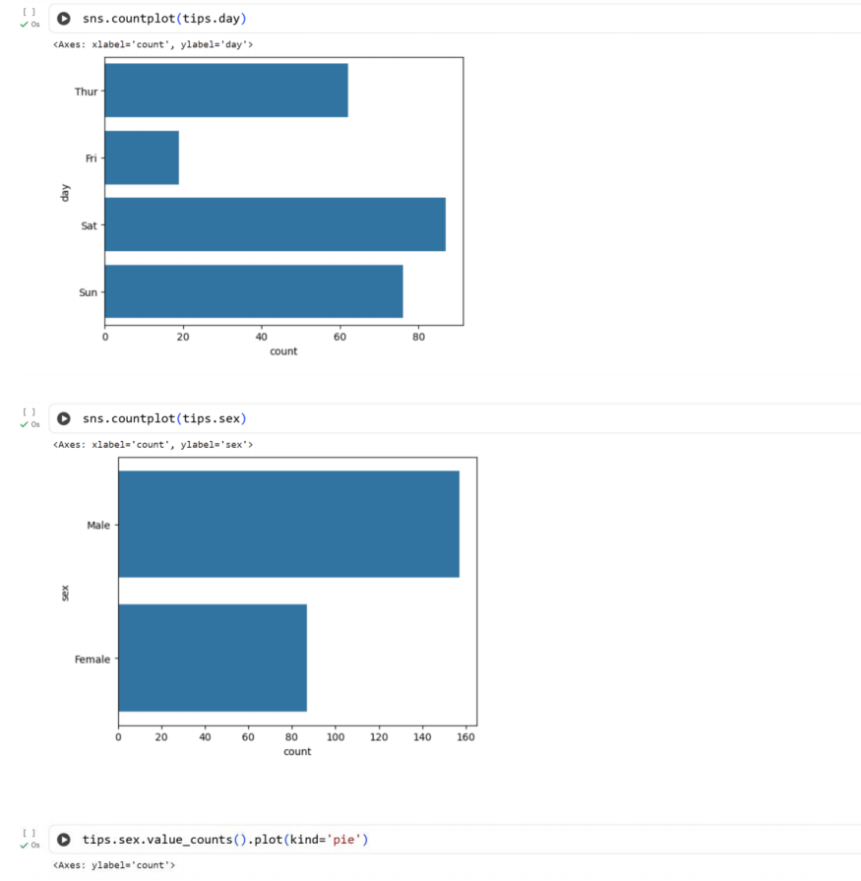
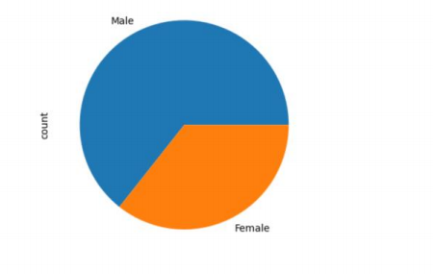
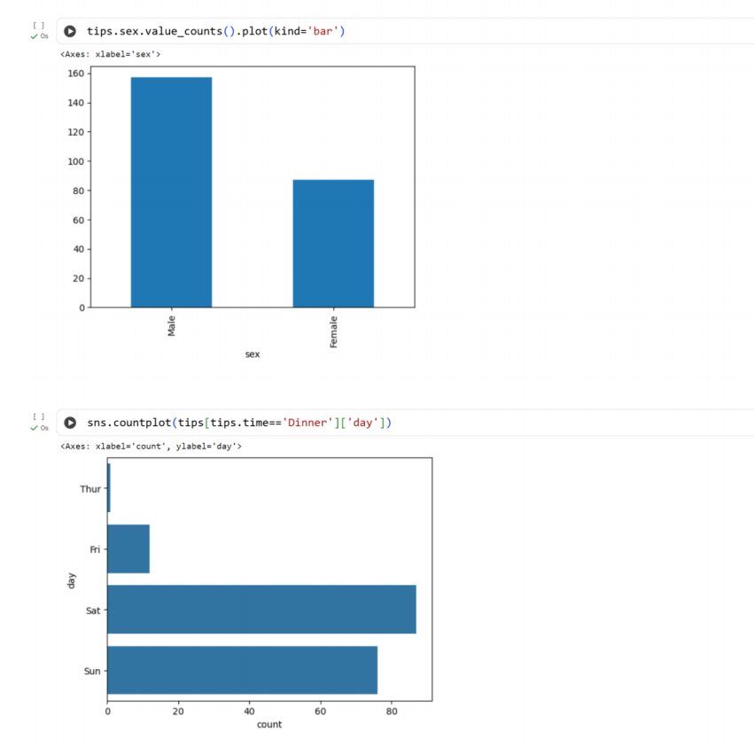
Result:
Thus the python program to understand EDA is executed and verified successfully

